Instruction for Use
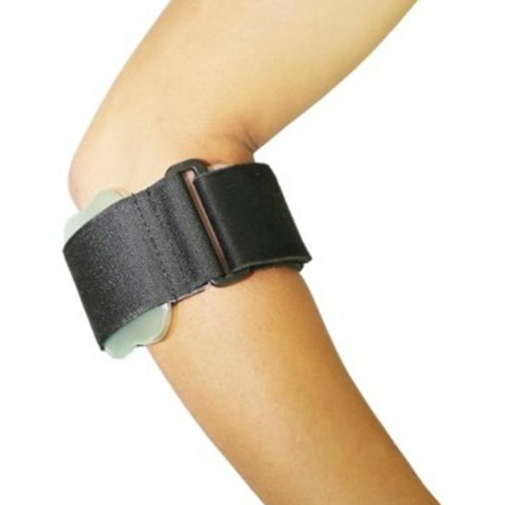

Common Examples of Use

Pain on the outer side of the elbow joint, movement pain, inability to grip objects with force, etc.Many athletes, housewives, bricklayers, carpenters, and others who repeatedly exert force on elbow movements for a long time are prone to tennis elbow.

WARNING:
This product should be given by an treating doctor and applied by a professional. Application should be done with great care to ensure correct fit and efficiency of the brace. For hygiene reasons, it is proposed to be used by a single patient. Recommended product use up to 2 years.

WASHING INSTRUCTIONS:
Check the condition of the product before use. If it is worn off, it needs replacement.
Hand wash with cold water. Use a soft detergent and remove the pads.
Allow to dry on its own. Do not wash it in a washing machine or dry it in a tumble dryer.

